**Network Layer: Data Plane**

* Network Layer
  + Sender: segment(transport layer) → datagram(network layer)
  + Receiver: datagram(network layer) → segment(transport layer)
  + Network layer protocols in every host, router
  + Router examines header fields in all IP datagrams passing through it
* Data vs Control plane
  + Data plane
    - Local, per-router function
      * Individual routing algorithm components in each and every router interact in the control plane
    - Determines how datagram arriving on router input port is forwarded to router output port
    - Forwarding function
  + Control plane
    - Network-wide logic
    - Determines how datagram is routed among routers along end-end path from source host to destination host
    - Two control-plane approaches
      * Traditional routing algorithms: implemented in routers
      * Software-defined networking (SDN): centralised (remote) servers
        + A distinct (typically remote) controller interacts with local control agents (CAs)

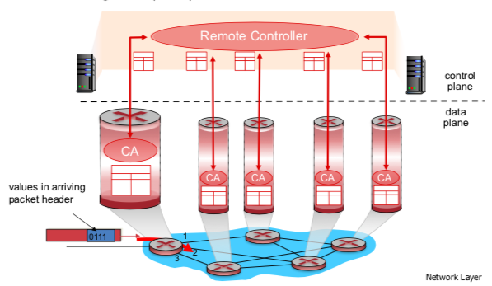

* Service model

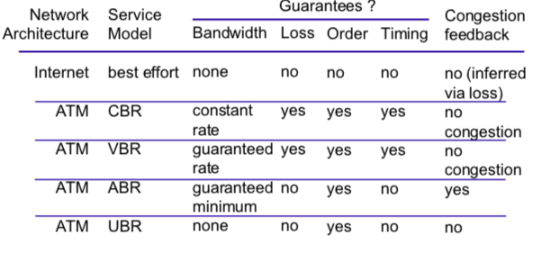

* IP (Internet Protocol)
  + In network layer:
    - Routing protocols: calculate information
    - Forwarding table: then save to here
    - IP: use the info in forwarding table
    - ICMP protocol: error reporting, router “signaling”
  + IP Packet Structure

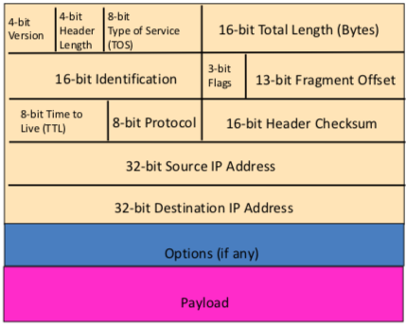

* + - Version: 4 or 6, means IPv4 or IPv6
    - Header length (4 Bytes): 5 typically
    - TOS: DiffServ 区分服务，一般不用，通常为00H
    - Total length (Byte): header (≥ 20B) + data = IP data (≤ 65535B)
    - TTL: preventing loops, decremented at each hop, packet discarded if reaches 0
    - Protocol: for de-multipux, e.g. 6 for TCP, 17 for UDP
    - Header Checksum: recalculated at every router, 计算时该字段置全0
    - Src/Dest IP Addr: 网络接口(主机/路由器) IP Address
  + IP fragmentation, reassembly
    - Note:
      * Why? Because different MTUs
      * Reassembled only at final destination
      * Fragmentation of fragments also supported
    - Identification: incremented at each fragment
    - Flags: true/false
      * DF (Don’t Fragment): 1 or 0
        + Drops the packet if it is too large (as DF is set)
        + Send ICMP message back to sender
      * MF (More Fragment): 1 or 0
    - Offset (8 Bytes): indicate position

